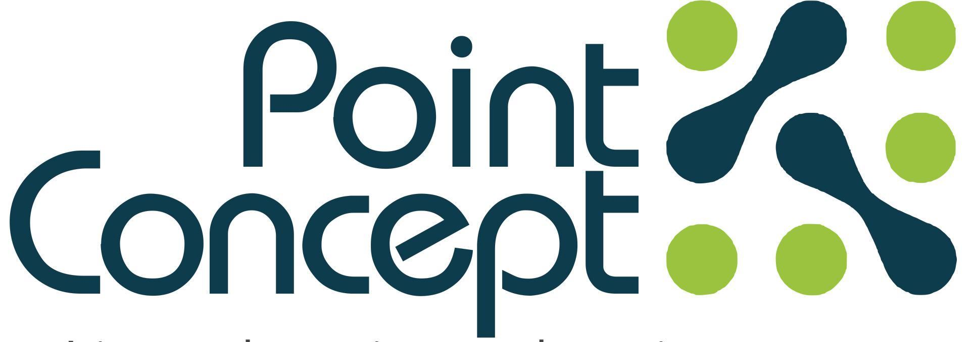
Architecture . Engineering . Construction . Project Management

POINT CONCEPT LIMITED
Point Concept Limited is a design and construction firm that provides excellence in engineering, construction, project management and building design services for residential, corporate and academic buildings.
Our design rigor combines with construction management experience to create a distinctive design process and end product that are intellectually and aesthetically rigorous as well as financially informed.
Who are we?
We are a Design and Building Construction Company.
Our Focus...
Our exclusive engineering focus is backed up by a team of highly motivated professionals cutting across the broad spectrum of engineering discipline.
Why Point Concept Limited
We operate on team approach bringing together owners, users and professionals in a collaboration of knowledge, needs and efforts, realizing greater results and enhanced solutions. We constantly strive to explore creative opportunities within each project undertaken.
What We Do...
- Architecture & Engineering Consulting Services
- Construction
- Renovation / Remodeling
- Building / Facility Management & Maintenance Services
- Interior Design / Construction
- Project Management
Our clients are assured:

- Value for money – loyalty, professional conduct
- Customer Service – confidentiality, professional manner
- Streamlined operations – efficient and effective service
- Project progress – clients kept informed
- Latest technology – producing professional detailed reports to achieve outstanding expeditious results.

List of Clientele
- Diamond Banks 
- Heritage Bank Branches 
- Redeemed Christian Church Of God 
- Emzor Pharmaceutical Industries Limited 
- Hubmart Stores (supermarket) 
- Private Individuals

Projects / Clients
- Diamond Banks Branches (consultancy)
- Ikota - Onne, Rivers State - Asaba 2, Delta State
- Akowonjo - Abak, Uyo
- Alaba 3 - Miriam Road, Calabar
- Oshodi - Mayne Avenue, Calabar
- Okota - Nike Lake, Enugu
- Addo, Ajah - Douglas Road, Owerri

- Heritage Bank Branches (consultancy)
- Dugbe, Ibadan
- Ashabi Cole, Ikeja, Lagos
- Adetokunbo Ademola, VI, Lagos
- Bodija, Ibadan

- Churches (consultancy & construction)
- Worship Centre for Agape Parish, RCCG, 8 Agoro Odiyan Street, VI, Lagos
- Worship Centre for Living Spring Parish, RCCG, Civil Service Club, 1 Awolowo Road, Ikoyi, Lagos
- Queen’s Court Estate, for Province 6, RCCG Camp, KM 46 Lagos-Ibadan Expressway.
- Province 6 Headquarters, RCCG, Osborne Phase 2, Ikoyi, Lagos. (consultancy)

Others
- Emzor Pharmaceutical Industries Limited (consultancy)
- Proposed warehouse at Ajao Industrial Layout, Lagos.
- Proposed Penicillin factory, Shagamu, Ogun State.
- Remodeling/out fitting of Theatre and Intensive care unit (ICU) for General Hospital, Marina, Lagos.
- Hubmart Stores, Adeola Odeku, Victoria Island, Lagos (consultancy).
- Redevelopment of Mojere Ultra Modern Spare Parts and Mechanic Workshops, Akure (consultancy).
- Residential Developments for private individuals at:
- Mayfair Garden Estate, Plots 675B, 753 & 754 (design & construction)
- Mobil Luxury Apartment, Lekki Phase1 (remodeling / renovation – 1 unit flat)
- 4nos. Luxury Terrace Residence at Agungi, Lekki, Lagos for Mr.
- 2 nos. Luxury Residences at Carlton Gate Estate, Lekki, Lagos

Management Team:
Cecil Akanno Managing Partner
Oladokun Kayode Architect / Project Manager
Olufemi Banire Civil/Structural Engineer
Chijioke Akanno Mechanical/Electrical Engineer
Olusola Okesanya Quantity Surveyor
Benjamin Oryina Office Manager
Roland Adebayo Administrative Manager
Ademola Yekini Project Supervisor
Sunday Shittu Project Supervisor

